Kevin Geraghty, Chairman  Michael Clerk, Vice Chairman  Ryan Fattman, Clerk  John L. Hebert  Michael Frustaci  Laura Rodgers, Acting Town Administrator  Jennifer Hager,  Assist Acting Town Administrator  Debra Jacques, Executive Assistant | 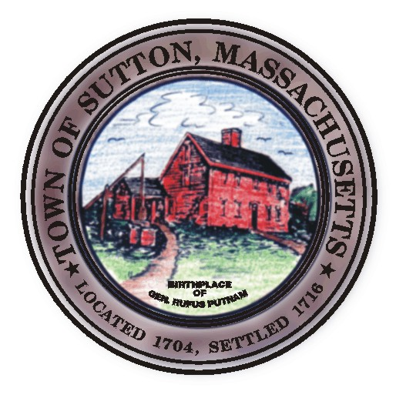 | Sutton Town Hall  4 Uxbridge Road  Sutton, Massachusetts 01590  (508) 865-8727  Fax: (508) 865-8721
Town Of Sutton
Board Of Selectmen

Meeting Agenda

7:00 p.m. – Tuesday, July 16, 2007

Sutton Town Hall, Selectmen’s Meeting Room

- Call to Order, Pledge of Allegiance at 7:00 p.m.

- Public Forum: Limited to 5 minutes per topic. Discussion or comments about town employees or agency members shall be avoided so as not to violate individual’s rights.
- Minutes and Proclamations
  - Consent Items (June 26, 2007 Minutes)
Executive Session (June 26, 2007 Minutes)

- Sponsored Agenda and Action Items
- William Marquis to discuss the Efficiency Review Committee
- Update of Shaw Farm Purchase
- Sutton Youth Baseball

- Town Administrator’s Update
- Aquarian Water
- Cable equipment room
- Set up workshop with Cable Comm.

- Announcements
VII. Selectman’s Roundtable: Correspondence and Business Topics
VIII. Executive Session
IX. Adjournment

